1. (1 mark)  
   Which statement is true?

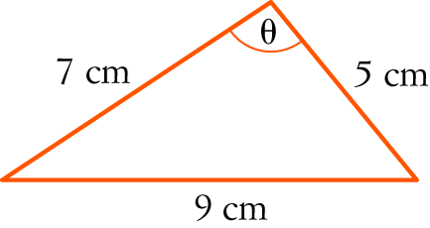

A  B 

C  D 

E 

1. (1 mark)  
   

A  B C  D  E 1

1. (1 mark)  
   Which statement is not correct?

A 

B 

C 

D sin (x − y) = sin (y) cos (x) − cos (y) sin (x)

E 

1. (1 mark)  
   Solve cos (2x) = −1 for 0 ≤ x ≤ 2π.

A x , B x  C x = 0, π, 2π D x  E x = π, 

1. (1 mark)  
   Find the amplitude and period of the following graph.

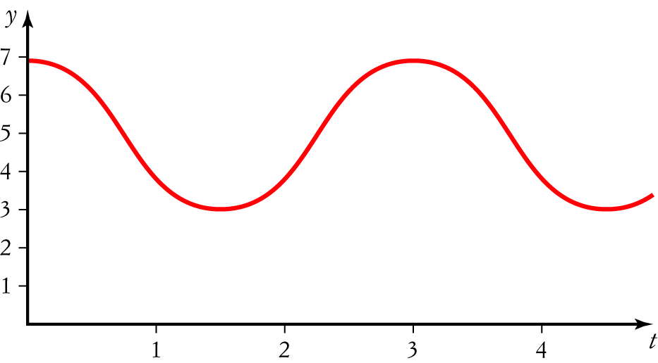

A Amplitude 4, period 4 B Amplitude 4, period 3

C Amplitude 4, period  D Amplitude 2, period 3

E Amplitude 2, period 

1. (1 mark)  
   The equation of the function below is:

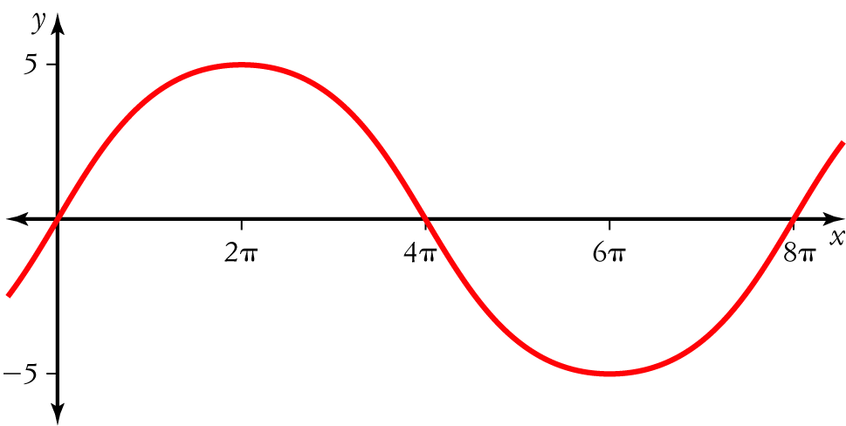

A  y = 8 sin (5 x) B  y = 5 sin (8 x)

C  y = 5 sin  D  y = 5 sin 

E  y = 5 sin (4πx)

7. (1 mark)  
Find the exact value of sin (105°).

A  B 

C  D 

E 

**Short and Extended Answer Questions – show working for questions worth more than 2 marks**

1. (2 marks)  
   Convert the following to radians, giving exact values.
2. 
3. 
4. (2 marks)  
   Convert the following radians to degrees.
5. 
6. 
7. (3 marks)  
   State which quadrant each of the following angles are in.
8. −285°
9. 
10. −
11. (6 marks)  
    Evaluate x correct to one decimal place.
12. 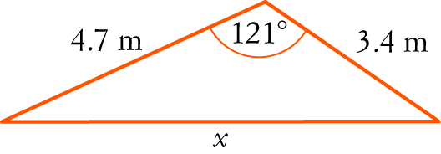
13. 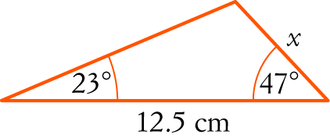
14. (5 marks)  
    If sin (a) =  and cos (b) = , find the exact value of cos (a + b)
15. (2 marks)  
    Using your CAS calculator, graph the functions y = 2 cos (x) and y = x − 1 on the same set of axes and graphically solve 2 cos (x) = x − 1 (you do not need to draw a graph).
16. (2 marks)  
    Expand
17. tan (2a + b)
18. cos (5a − 3b)
19. (5 marks)  
    The circumference of a circle is 20 cm. Find the angle subtended at the centre if it cuts off a sector with an area of 15 cm2.
20. (3 marks)  
    Show that cos (2x) = 1 − 2 sin2 (x)
21. (6 marks)  
    Solve
22. cos (x) =  for 0 ≤ x ≤ 2π
23. Solve 2 sin2 (θ) − 1 = 0 for 0° ≤ θ ≤ 360°.
24. (13 marks)  
     The diagram below shows a regular pentagon with sides of 10 m.

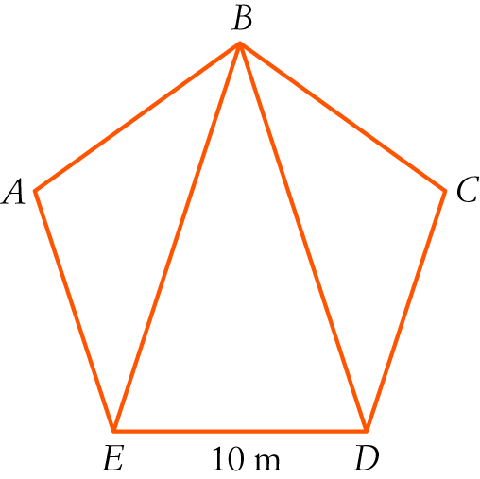

1. Use the sum of angles in a triangle to find the angle sum of any pentagon. [1]
2. Find the size of each angle inside a regular pentagon. [1]
3. Find the length of BE in the pentagon above. [3]
4. Find the area of the pentagon. [8]

More space available over page.

**End of Test**